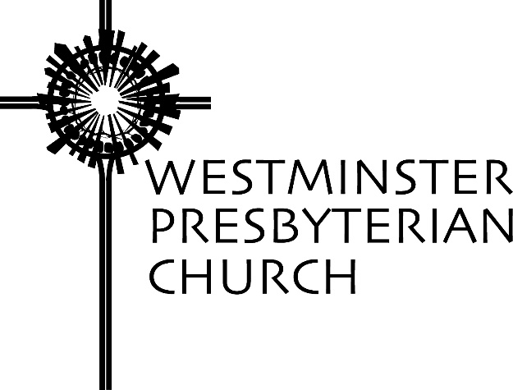

“The Palms and the Passion”
Scripture – Matthew 21:1-11
Sermon preached by Gregory Knox Jones
Sunday, April 9, 2017

“Hosanna to the son of David!” That was the cry of his followers as Jesus entered Jerusalem. The question that hangs in the air is: Why did he make a spectacle of his entrance? Jesus was a walker. He walked everywhere he went. He entered numerous villages during his ministry and he always walked. His followers traipsed along with him.

However, his entrance into Jerusalem was noticeably different. He rode in on a donkey. People shouted “Hosanna!” Some threw their cloaks on the ground before him. Others tossed down palm branches. Why the theatrics?

Over time, the church has remade this event into something akin to a Thanksgiving Day parade. We wave palm branches as if they were pom-poms and shout “Hosanna!” with the same cheery enthusiasm we would howl “Hooray!” Admittedly, we are missing the floats and the giant helium-filled cartoon characters, but everyone still loves a parade, right?

I fear that over time, the church has siphoned off the vigor of that first Palm Sunday processional by replacing the original event with something far tamer. However, the Walt Disney veneer that has been tacked on belies the essence of what Jesus and his followers did the day he entered Jerusalem.

The story of Jesus’ entry was a critical episode in the early church. Why else would the authors of all four gospels write about it?

The baptism of Jesus and the story of his resurrection are included in all four, but think of what did not make the cut in all of the gospels. The Christmas story appears only in Matthew and Luke. Mark and John say nothing of the birth of Jesus. The same is true of the Lord’s Prayer and the Beatitudes. They appear in only two of the four. The beloved Parable of the Good Samaritan occurs only in Luke. The other three fail to mention it.

So, why is the story of Jesus entering Jerusalem so significant?

During the course of his ministry, Jesus visited numerous villages in Palestine. But at some point, he decided to chart his course for Jerusalem, the seat of religious authority and the home of his fiercest opponents. He planned his entry into the Holy City carefully. He entered a few days before the Passover Feast, a time when pilgrims from near and far had swollen the city to four or five times its normal size.

Jesus selected this precise moment because this was the religious festival when Jews celebrated God liberating them from slavery in Egypt. Now that they lived under the oppressive regime of Rome, they dreamt of another liberation.

The Romans were wary of this week and hoped to survive it without an incident. With more than 200,000 Jews celebrating an earlier liberation, Jerusalem was a tinder box that any spark might ignite. It fell to Pontius Pilate, the Roman Governor whose territory included Jerusalem, to insure that nothing got out of hand.

Pilate’s residence was 60 miles west of Jerusalem overlooking the pristine waters of the Mediterranean. Each year at Passover, he marched into Jerusalem with a show of force to remind everyone who was in charge. Surrounded by armed soldiers, Pilate rode through the west gate of Jerusalem atop a mighty stallion. Onlookers gathered along the side of the road to witness – and most likely shudder – at this intimidating display of muscle. I picture the scene similar to those black and white newsreels from the thirties and forties that showed waves of Nazis marching through cities in Europe.

First century Jews despised the Romans who oppressed them with strict laws, heavy taxes, and occasional brutality. The people longed for the Messiah to appear and set things right. Many imagined that the Messiah would come with an equally impressive army. He would topple the Romans and then be crowned the King of the Jews.

Like Pilate, Jesus also carefully choreographed his entrance into the Holy City. Pilate entered from the west, Jesus entered from the east. Pilate strutted in atop a mighty steed, Jesus lumbered in on a lowly donkey. Pilate entered surrounded by crack soldiers, Jesus entered surrounded by fisherman, farmers, at least one tax collector and a handful of women. Pilate’s troops wielded swords and spears, Jesus’ contingent brandished palm branches. Pilate’s army hailed Caesar, Jesus’ crew shouted “Hosanna!”

It helps to know that “Hosanna!” does not mean “Hooray” or “Alleluia!” It means “save us” or “deliver us.” That is, the people were calling on Jesus to deliver them from the Roman occupation. And when they called him “Son of David,” their legendary king and mightiest military leader, it was tantamount to treason. Later in the week, after Jesus was arrested and dragged before Pilate, remember what Pilate asked him? Are you the King of the Jews?

The day Jesus entered Jerusalem was the day his followers changed from passive observers to active protesters. Up to this point, his followers had been almost exclusively onlookers. They had watched Jesus heal, they had listened to him teach, they had witnessed him confronting religious leaders; but they had been short on action. Palm Sunday is the day they engaged in peaceful resistance. They very publicly announced their allegiance not to Caesar, but to Jesus; not to Rome, but to the Kingdom of God; not to oppression, but to justice; not to cruelty, but to compassion; not to violence, but to peace.

Their non-violent protest reminds us that you can resist with hatred in your heart, or love in your heart. Jesus calls on his followers to oppose injustice with righteous anger, but not with malice.

He left his disciples with an unforgettable picture. After entering the gates of the city, he went up to the temple where he flipped the tables of the moneychangers and drove out those who were buying and selling. He accused the temple leaders of turning God’s house of prayer into a den of robbers, because they were in collusion with the occupying Romans and skimming shekels off the poor.

Over the next few days the chief priests, the elders, the Pharisees and the Sadducees took turns peppering Jesus with trick questions. They hoped to embarrass Jesus in front of his followers, but Jesus outdueled them in the verbal skirmishes. He told parables exposing the hypocrisy and the corruption of the religious leaders widening the gulf between his way and that of the religious establishment.

Within days, the powers struck back – and with a vengeance. One of the twelve – Judas – sold out and betrayed Jesus. But he was not the only one. When Jesus was in his hour of greatest need, he took Peter, James and John with him to the Garden of Gethsemane. He said, “Remain here and stay awake with me.” They fell asleep. After Jesus was arrested and interrogated by Pilate, Peter denied knowing him. The other disciples vanished.

Jesus was beaten, whipped, and finally had nails driven through his hands and feet. The pain must have been unimaginable. And yet, somehow, he did not give in to hatred. Even though he was filled with holy anger toward their unjust actions, Jesus never forgot that they, too, were children of God. He knew that anyone – including you and me – might give in to the dark side because we are misinformed or misguided or afraid.

After betrayal, beatings, humiliation, and immense pain, Jesus hung on the cross and spoke those haunting words: “Father, forgive them; for they do not know what they are doing.”

Jesus was not saying that we are to acquiesce in the face of injustice. He was not saying that all those who took part in the path that led to his death should not feel remorse. He was not saying that there are no consequences to our choices. He was not saying we should not change course. He was praying for God to do what God does – show mercy.

However, his words were not aimed at God. They were spoken for our benefit. God does not need to be reminded to be forgiving, but we need to be reminded that God is forgiving. More to the point, he was setting an example for his followers.

If Jesus can forgive people who are literally killing him, how can I not forgive others for far less egregious acts?

That is not to say that forgiveness is easy. When someone has really hurt you, you know how difficult it can be.

In 1961, six-year-old Ruby Bridges walked every day to a white school in New Orleans. Picture this: Surrounded by federal marshals, this little girl had to traverse a gauntlet of angry white tormentors who insulted her, threatened her and spit on her. As she walked the line of malice, you could see her lips moving. Was she responding to the vile hurled at her? Was she cursing their existence? A Harvard psychiatrist talked with her, “What are you saying, Ruby?” She replied shyly, “I’m praying: Please dear God, forgive them, because they don’t know what they’re doing.”¹

Jesus stood up against injustice and he resisted the powers of oppression, indifference and violence. Yet, he did not fight hate with hate. He did not fight violence with violence, because he was forever motivated by love. He did not seek the destruction of his opponents, but rather, their transformation.

Can we resist the knee jerk reaction of revenge? Can we do the much tougher, more disciplined, more time-consuming work of peace? Not, “Let’s all hold hands and sing Kum Ba Yah,” but hammering out our differences without using a hammer? Seeking justice, but rather than seeking the annihilation of our adversaries, praying for their transformation.
Westminster Presbyterian Church 1502 West 13th Street Wilmington, DE 19806 (302) 654-5214 www.wpc.org
Can we do the hard, holy work of Jesus?

NOTES

- Kent Ira Goff quoting from Robert Coles, The Moral Life of Children.

